Name: Samil Shah

Assignment 1

1

**Code:**

**data** textbooks;

Input Dept_abb $ **1**-**4** Course_Number **5**-**9** Price **10**-**16** Book_Req $ **17**-**28**;

Datalines;

ISM 6963 10 Required

ISM 6962 20 Optional

QMB 6964 100 Recommended

ISM 6137 50 Required

ISM 6218 70 Optional

ISM 6436 90 Optional

ISM 6930 150 Recommended

ME 7102 28 Required

BE 8964 56 Optional

ISM 6123 90.45 Recommended

;

**PROC** **PRINT** DATA=textbooks;

Title "TextBooks";

**Run**;

**Log file:**

611 data textbooks;

612 Input Dept_abb $ 1-4 Course_Number 5-9 Price 10-16 Book_Req $ 17-28;

613 Datalines;

NOTE: The data set WORK.TEXTBOOKS has 10 observations and 4 variables.

NOTE: DATA statement used (Total process time):

real time 0.00 seconds

cpu time 0.00 seconds

624 ;

625 PROC PRINT DATA=textbooks;

626 Title "TextBooks";

627 Run;

NOTE: There were 10 observations read from the data set WORK.TEXTBOOKS.

NOTE: PROCEDURE PRINT used (Total process time):

real time 0.10 seconds

cpu time 0.01 seconds

**Output:**

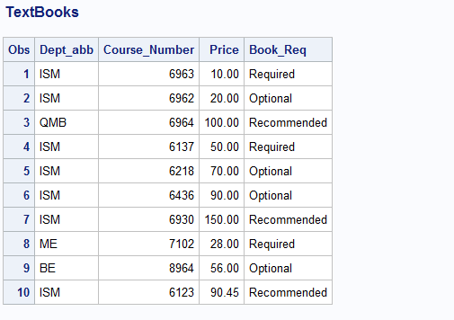

2 **Code:**

**data** softdrink;

Input Name $ **1**-**10** Type $ **11**-**21** Price **22**-**27** Sold_Out $ **28**-**32**;

Datalines;

Pepsi Can 2.45 No

Coke Can 1.78 Yes

Ice Tea Bottle 2.5 No

Thums Up Bottle 4.87 Yes

Fanta Bottle 3.96 No

Lemon Bottle 5.37 No

Sprite Bottle 2.97 No

Izze Juice Box 3.97 Yes

Grapico Paper Cup 6 No

Diet Rite Bottle 12.90 Yes

;

**PROC** **PRINT** DATA=softdrink;

Title "Soft Drink Dispensing Machine";

**Run**;

**Log File:**

783 data softdrink;

784 Input Name $ 1-10 Type $ 11-21 Price 22-27 Sold_Out $ 28-32;

785 Datalines;

NOTE: The data set WORK.SOFTDRINK has 10 observations and 4 variables.

NOTE: DATA statement used (Total process time):

real time 0.01 seconds

cpu time 0.01 seconds

796 ;

797 PROC PRINT DATA=softdrink;

798 Title "Soft Drink Dispensing Machine";

799 Run;

NOTE: There were 10 observations read from the data set WORK.SOFTDRINK.

NOTE: PROCEDURE PRINT used (Total process time):

real time 0.10 seconds

cpu time 0.01 seconds

**Output:**

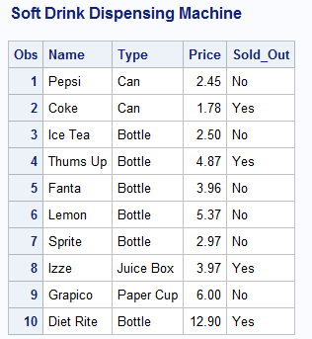

**3 Code:**

**data** apartment;

Input BR **1**-**3** BA **4**-**7** Rent **8**-**13** Phone $ **14**-**25**;

Datalines;

1 1 600 8138989283

2 1 1000 8135665262

1 1 550 8134578999

4 4 2000 8124568928

2 2 1180 8134252797

3 2 1460 8136989286

3 3 1700 8136665265

2 2 1000 8132578994

4 4 2200 8128568923

2 2 1080 8135252792

;

**PROC** **PRINT** DATA=apartment;

Title "Apartment Housing in the Tampa Bay Newspaper";

**Run**;

**Log File:**

902 data apartment;

903 Input BR 1-3 BA 4-7 Rent 8-13 Phone $ 14-25;

904 Datalines;

NOTE: The data set WORK.APARTMENT has 10 observations and 4 variables.

NOTE: DATA statement used (Total process time):

real time 0.00 seconds

cpu time 0.01 seconds

915 ;

916 PROC PRINT DATA=apartment;

917 Title "Apartment Housing in the Tampa Bay Newspaper";

918 Run;

NOTE: There were 10 observations read from the data set WORK.APARTMENT.

NOTE: PROCEDURE PRINT used (Total process time):

real time 0.11 seconds

cpu time 0.01 seconds

**Output:**

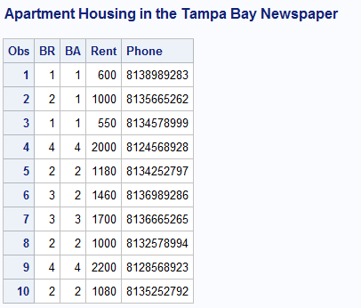

**4**

* DOLLARS$ - This variable is not accepted by SAS as a special character is used $. As it is used to specify the data type character.
* DIAMETER - This variable is accepted.
* 8Y - This variable is not accepted by SAS as a numeric value is used to start the name of the

variable.

* TREATMENT - This variable is accepted.
* _PPX4T_G - This variable is accepted.

**5**

* 1982DATA - This variable cannot be used in the dataset. As the variable is starting with a

numeric value.

* DATA#1 - This variable cannot be used in the dataset. As the variable is having a special

character.

* D_A_T_A_ - This variable is accepted.
* TRIALDATA - This variable is accepted.
* BARNEY - This variable is accepted.

**6**

**Code:**

**Data** players;

Input Name $ **1**-**6** T_No $ **7**-**9**;

Datalines;

John 0

Kobe 00

;

**PROC** **PRINT** DATA=players;

Title "BasketBall Team Jersey No";

**Run**;

Log file:

1004 Data players;

1005 Input Name $ 1-6 T_No $ 7-9;

1006 Datalines;

NOTE: The data set WORK.PLAYERS has 2 observations and 2 variables.

NOTE: DATA statement used (Total process time):

real time 0.01 seconds

cpu time 0.01 seconds

1009 ;

1010 PROC PRINT DATA=players;

1011 Title "BasketBall Team Jersey No";

1012 Run;

NOTE: There were 2 observations read from the data set WORK.PLAYERS.

NOTE: PROCEDURE PRINT used (Total process time):

real time 0.29 seconds

cpu time 0.01 seconds

Output:

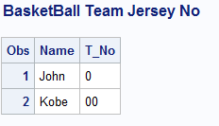

**7**

**Valid variables**

* Height
* HeingtInCentimeters
* Height_in_centimeters
* X123y456
* MiXedCasE

**8**

Clinic - VALID

clinic - VALID

work - VALID

hyphens-in-the-name - INVALID

123GO - INVALID

Demographics_2006 - VALID

**9**

1. The number of variables is _5_
2. The number of observations is __10__

**10**

1. You can place more than one SAS statement on a single line. - True
2. You can use several lines for a single SAS statement. -True
3. SAS has three data types: character, numeric, and integer. - False
4. OPTIONS and TITLE statements are considered global statements. - True

**11**

8 bytes is the default storage length for SAS numeric variables.